Customer Shopping Analysis

1. Project Overview
This project analyzes e-commerce purchasing behavior using order data from approximately 30,000 online transactions generated between January 2023 and December 2026. The objective was to uncover insights into customer demographics, membership programs, product performance, marketing effectiveness, and purchasing trends to support data-driven business decisions.
The project followed a complete analytics workflow consisting of data preparation and feature engineering in Python, business analysis using PostgreSQL, and interactive dashboard development in Power BI.

2. Dataset Summary
- Rows: Approximately 30,000 transactions
- Columns: 40+ features
- Reporting Period: January 2023 – December 2026

3. Exploratory Data Analysis using Python
Data cleaning and exploration:
- Data loading: Imported the dataset using pandas.
- Initial Exploration: Used df.info() to check structure and .describe() for summary statistics.

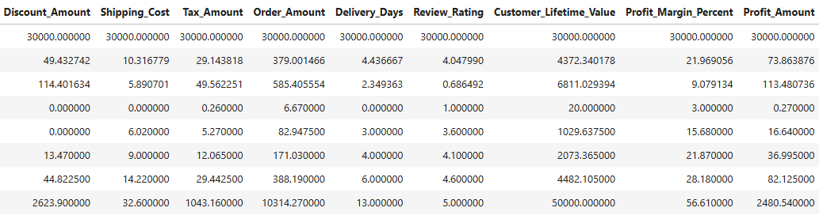
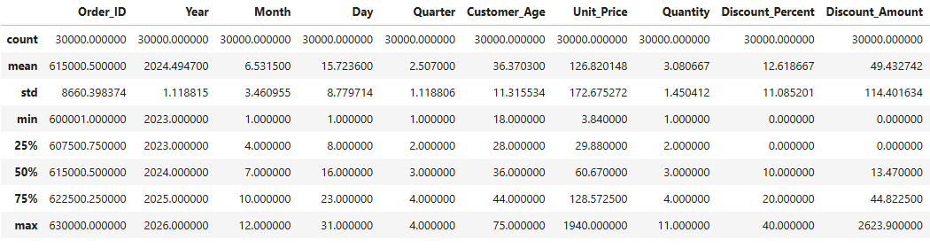
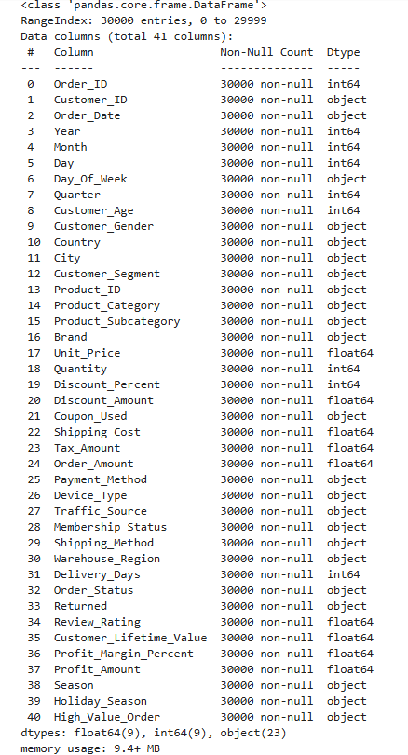
- Missing Data: Checked for null values
- Column Standardization: Renamed columns to snake case for better readability documentation.
- Feature Engineering:
  - Created age_group column by binning customer ages.
  - Created customer_lifetime_value_tier column by binning customer lifetime.
  - Created gross_sales_amount column using unit price and purchase quantity
- Database Integration: Connected Python script to PostgreSQL and loaded the cleaned data frame into the database for SQL analysis.

4. Data Analysis using SQL
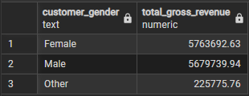
- Revenue by Gender – Compared total revenue generated by male vs. female customers.
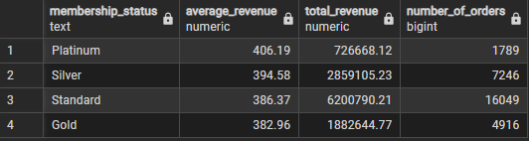
- Membership Tier Analysis – Compared average order value, total revenue, and transaction counts across membership tiers.
- Top 3 product subcategories per Category – Listed the most purchased product subcategories within each category.
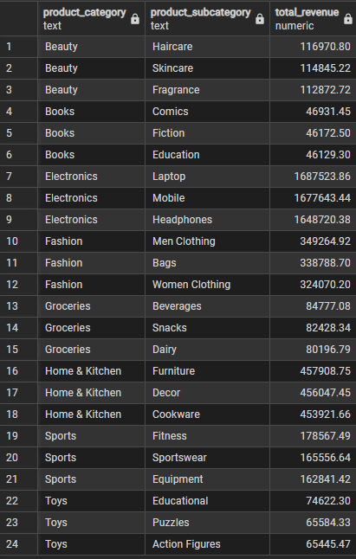
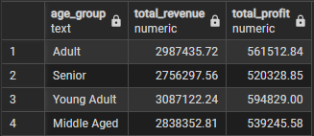
- Revenue and Profit by Age Group – Calculated total revenue and profit contribution of each age group.
- Top Traffic Sources by Age Group – Identified the highest revenue-generating traffic source within each age group.

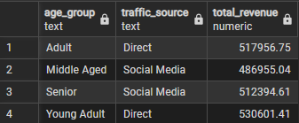
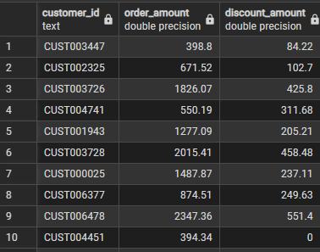
- High-Spending Discount Users – Identified customers who used discounts but still spent above the average purchase amount.
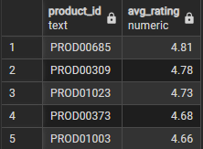
- Top 5 Products by Rating – Found products with the highest average review ratings.
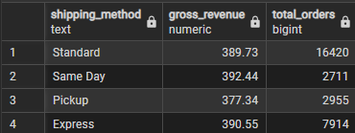
- Shipping Method Comparison – Compared average order values across shipping methods.
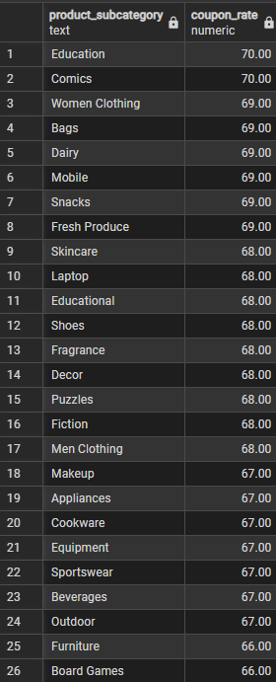
- Discount-Dependent Subcategories – Identified subcategories with the highest percentage of discounted purchases.
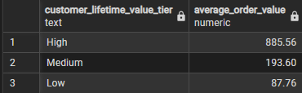
- Customer Lifetime Value Analysis – Compared average order values across customer lifetime value tiers.

5. Dashboard in Power BI
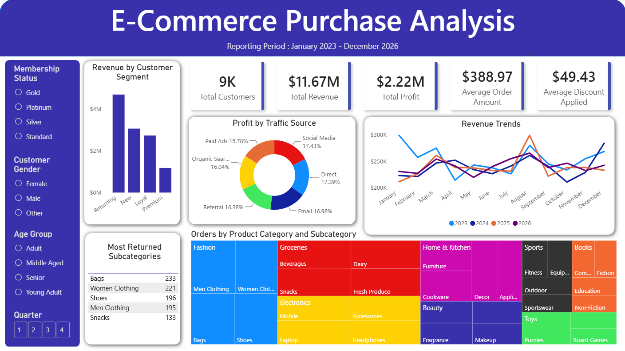
Built an interactive dashboard in Power BI to present insights visually.

6. Business Recommendations
- Boost Subscriptions – Promote exclusive benefits for different membership tiers.
- Target Traffic Channels by Demographics - Tailor ad campaigns to the highest-performing traffic sources identified for each specific age group.
- Tier Upgrades - Design exclusive perks or targeted upgrade campaigns for high-value tiers to further push the average order value.
- Product Positioning – Highlight top-rated products in campaigns.
- Optimize Discount Dependencies - Shift toward bundle offers or loyalty points to ensure heavy coupon reliance isn't eroding profit margins.
- Reward High-Value Coupon Users - Create a segmented "High-Value Value Shopper" cohort for customers who use discounts but maintain above-average order amounts, targeting them with exclusive, high-threshold offers.

